# Simple Car Rental System Design

#### Requirement Assumptions

* System manager can register a new car and update the information for each car. Each car has a unique plate number.
* User can register an account and login to this system.
* User can know what date can be reserved in advance.
* User can order a car for a date range. It has no intersection with others’ order.
* User can check his orders in his user center.
* Service instance can be increased and decreased automatically based on workload

#### User Case Diagram

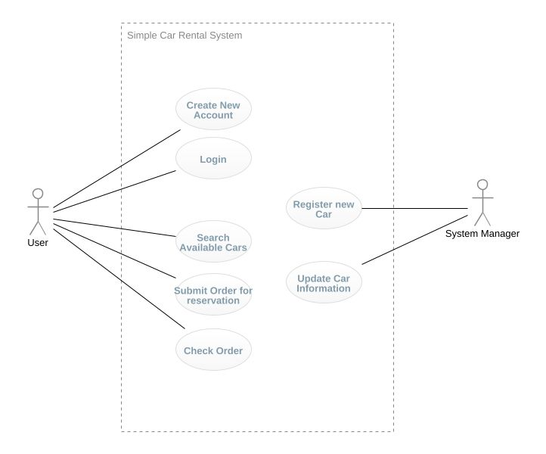

#### API Spec

You can interact with each api via the following URL.

API DEMO : <http://alb-rental-1893816961.us-east-1.elb.amazonaws.com:8080/swagger-ui.html#/>

|  |  |  |
| --- | --- | --- |
| **API** | **HTTTP Method** | **Description** |
| [**/cars**](http://alb-rental-1893816961.us-east-1.elb.amazonaws.com:8080/swagger-ui.html#/operations/car-controller/searchCarsUsingGET) | POST | Register a new car |
| [**/cars**](http://alb-rental-1893816961.us-east-1.elb.amazonaws.com:8080/swagger-ui.html#/operations/car-controller/registerCarUsingPOST) | GET | Search available cars |
| [**/cars/{carId}**](http://alb-rental-1893816961.us-east-1.elb.amazonaws.com:8080/swagger-ui.html#/operations/car-controller/updateCarUsingPUT) | PUT | Update a car’s information |
| [**/orders**](http://alb-rental-1893816961.us-east-1.elb.amazonaws.com:8080/swagger-ui.html#/operations/order-controller/getOrdersUsingGET) | POST | Submit an order for reservation |
| [**/orders**](http://alb-rental-1893816961.us-east-1.elb.amazonaws.com:8080/swagger-ui.html#/operations/order-controller/createOrderUsingPOST) | GET | Search orders |
| [**/users**](http://alb-rental-1893816961.us-east-1.elb.amazonaws.com:8080/swagger-ui.html#/operations/user-controller/registerUserUsingPOST) | POST | Register a new user |
| [**/users/login**](http://alb-rental-1893816961.us-east-1.elb.amazonaws.com:8080/swagger-ui.html#/operations/user-controller/loginUsingPOST) | POST | Login for user |
| [**/health**](http://alb-rental-1893816961.us-east-1.elb.amazonaws.com:8080/swagger-ui.html#/operations/health-controller/healthUsingGET) | GET | Health check for load balance |

#### Technical Architecture

* The system was developed by Java with spring boot framework
* The backend database is mysql.
* Conforms to the constraints of REST architectural style
* The built docker image should be pushed to AWS Repository, and hosted by AWS ECS.
* There is also a load balancer to forward your requests to several service instances.
* The service cluster is scalable based on CPU/Memory.

#### Code Path

Github : <https://github.com/ahuoo/rental.git>

#### Test cases

You can find the test cases under test folder in source code.

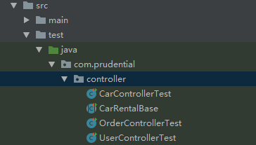

#### Cloud Deployment Architecture

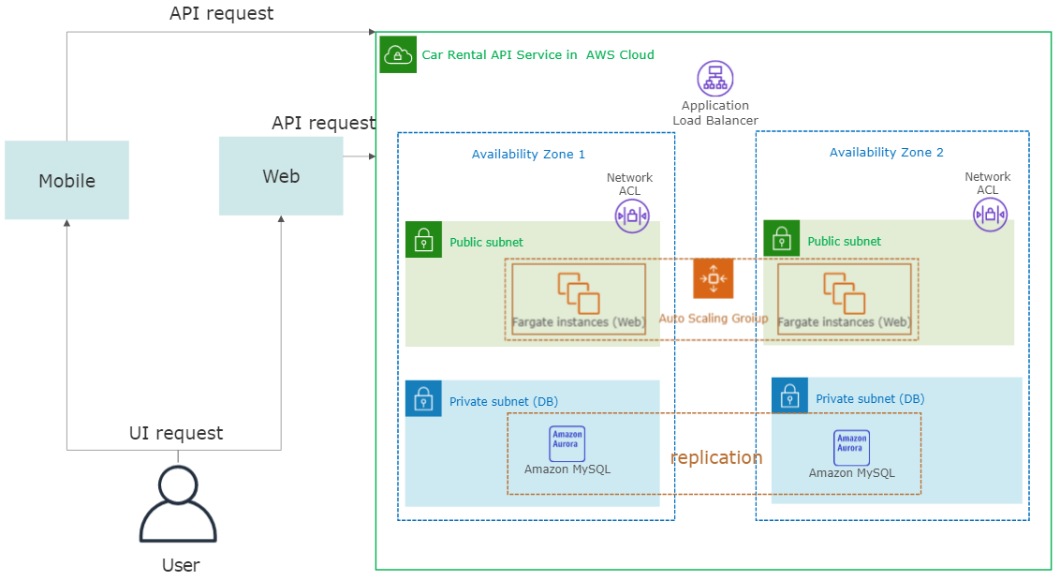

#### Web Client Demo for API

Since I have a personal web site developed by PHP, so I implemented a simple demo with above APIs. You can access it via address: <http://ahuoo.com/rental/>

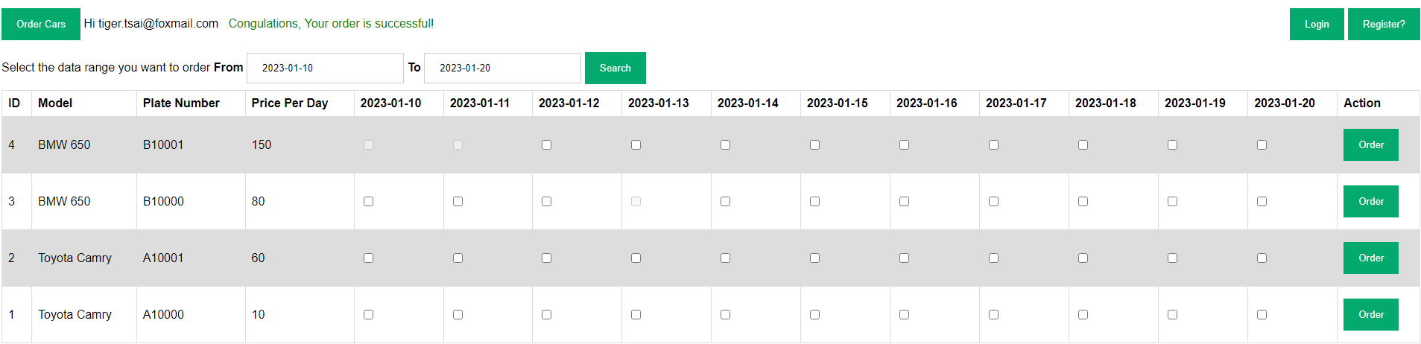

In this page, You can:

* Register a new User
* Login
* Submit an order
* Check what dates are available for reservation, The disabled checkbox means that date is ordered by other people.